2023-2024 Florida SUS Admissions Matrix

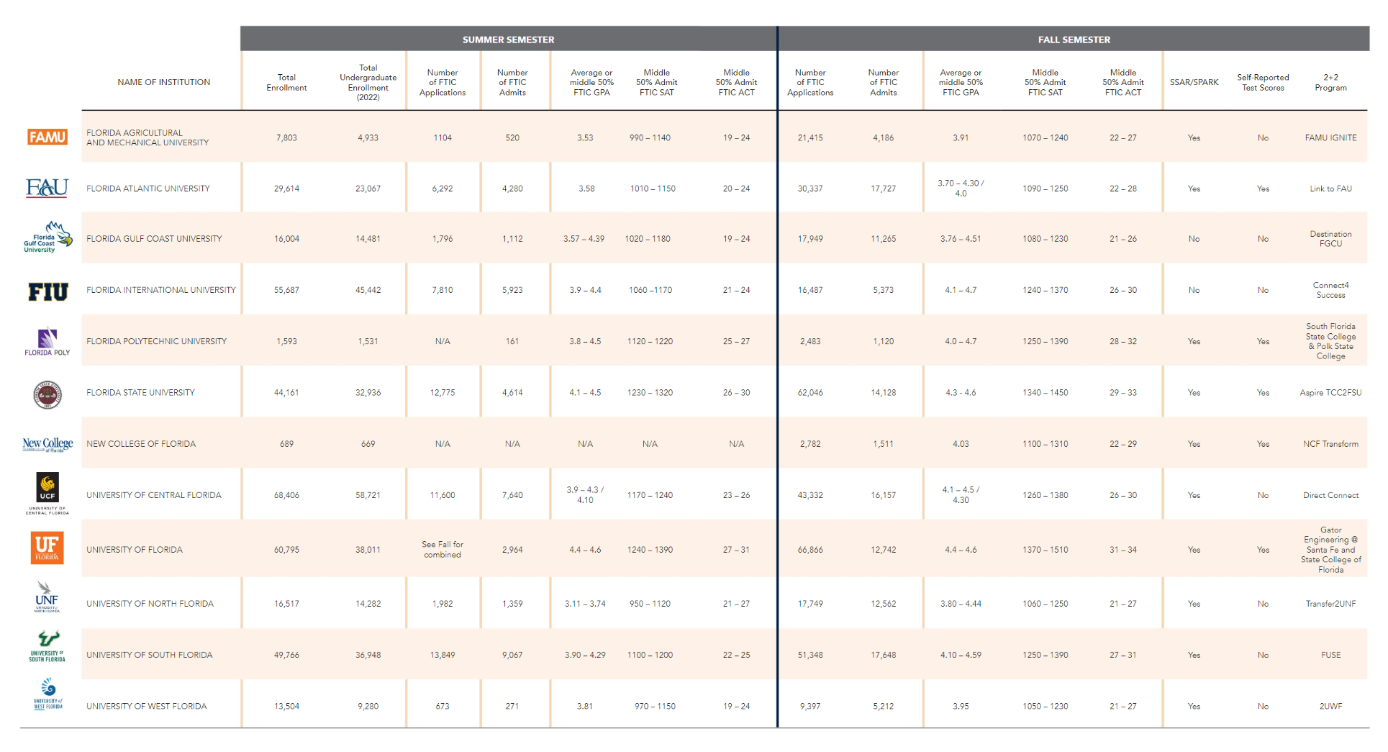

This is information is found in the 2023-2024 Counselor Guide (pages 12-13)

