Cambridge AICE FAQs
Q: What is AICE?
A: The Advanced International Certificate of Education (AICE) is an internationally recognized diploma awarded to students for the satisfactory completion of a series of academically rigorous courses specific to AICE in high school. Students who pass individual AICE exams will earn college credit for those exams passed. The AICE program is equivalent to IB…with the advantage of having flexibility to take AICE courses based on students strengthens and interest.
Q: What are the benefits of AICE?
A: AICE not only prepares students to enter college with up to 30 hours of credit, it also provides them with the skills required to be successful once there. In addition, students who earn the AICE Diploma will qualify for the Florida Academic Bright Futures Scholarship. See AICE Counselor for more information.
Q: What do I have to do to earn an AICE Diploma?
A: Students must pass seven credits worth of examinations. At least one examination must come from each of the four subject groups: Mathematics and Sciences, Languages, Arts and Humanities, and Interdisciplinary Skills Based.
Q: Do students have to earn the full AICE Diploma in order to earn college credits?
A: No. Colleges award credit on a subject–by–subject basis according to grades earned on individual examinations passed.
Q: Do many universities give college credits for AICE exams passed?
A: Yes. University of Cambridge International Examinations publishes a list on their website (go to www.cie.org.uk click on the ‘Recognition’ tab and then scroll down to the ‘Useful documents’ section) of US universities that have provided written statements of their AICE recognition policy.
Q: Do all of the schools in Florida accept AICE exams?
A: Yes. All of the colleges and universities in Florida honor AICE Exams and give credit for passing scores.
Q: How many college credits can be earned through AICE?
A: Colleges and universities can award between 30 and 45 credit hours.
Q: Does AICE help towards Florida Bright Futures?
A: If a student earns an AICE Diploma, complete 100 hours of community service, and fill out the Florida Financial Aid Application and the student will automatically earn the Academic Scholars Award. You will not have to get the benchmark score on the ACT or SAT
How do AICE examination grades compare with US Grading Scale?
Passing grades available on AICE exams range from A to E with A being the highest. Below is a comparison chart for US Grades, AP scores and Cambridge Grading Scale
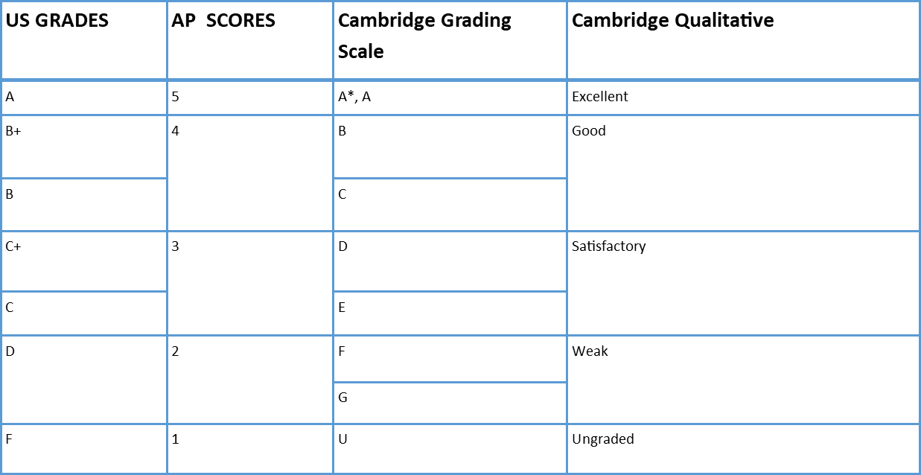
Q: What courses does Sumner High School offer?
A: Our potential course offerings for the 2021-2022 school year include the following AS Level Courses
Group 1: Math & Sciences | Group 2: Languages | Group 3: Arts & Humanities | Group 4: Interdisciplinary
AICE Math  AICE Biology  AICE Marine Science  AICE Informational Technology  AICE Environmental Management*  AICE Psychology*  AICE Physical Education* | AICE English Language  AICE Spanish | AICE US History  AICE European History  AICE Drama  AICE Music  AICE Media Studies  AICE Environmental Management*  AICE Psychology*  AICE Physical Education* | AICE English General Paper  AICE Thinking Skills
Core: All AICE Diploma students will take AICE Global Perspectives
*Course may count towards Group 1 or Group 3

