**The State of Tampa Heights SAC Synopsis: March 25, 2021**

**School Improvement Plan:**

School Data: we are two weeks out until our testing window opens for FSA Writing for 4th and 5th grades.

Current Intervention Groups: All lunch bunch, ELP and Morning Academic groups are in full swing as testing is fast approaching.

Parents who have questions or concerns about testing should contact their child’s teacher.

**Title I:**

The Title I E-Box and PIN (Parent Information Notebook) is up to date.

Title I $2000.00: we purchased award pins, cardstock for awards, printer ink, and items were purchased (flash cards, dry erase boards and markers, word-building tiles and mats, and addition and subtraction color by number) for a parent resource center for parents to check out to use at home or for teachers to send home as supplemental resources for individual students

Potential Barriers Survey – a link was sent to parents before Spring Break though parent group emails (on 3/1/2021 and on 3/4/2021) to complete this one-minute survey to help us better meet parent needs and plan for parent engagement. As a Title I school we like to include parents in all decisions. If you have not completed the survey, please follow this link:

<https://forms.office.com/Pages/ResponsePage.aspx?id=-f2oEP_CDU6cGR_iwYgWSk0lqwOkuUBMnGAEgE8kiMtUQTI3VTdBSE9DS0FCVkdRVUVPSUc3MTZHVy4u>

Results thus far (36 completed surveys):

Are SAC/PTA meetings, which are held virtually @ 6:00pm once evening per month convenient for you to attend?

75% Yes (27) 25% No (9)

Do you feel there is adequate communication coming home about school meetings/events?

81% Yes (29) 18% No (7)

Do you enjoy receiving and reading our quarterly newsletters?

100% (36)

How can we help make joining PTA easier for you?

14 I’m already a member of PTA.

6 I need help joining electronically.

16 I need more information about the value of joining PTA.

**Old Business:**

2nd Magnet Application period ends Thursday, March 25.

House System Update – the Friday before Spring Break, we celebrated by sorting our children into our four Houses:

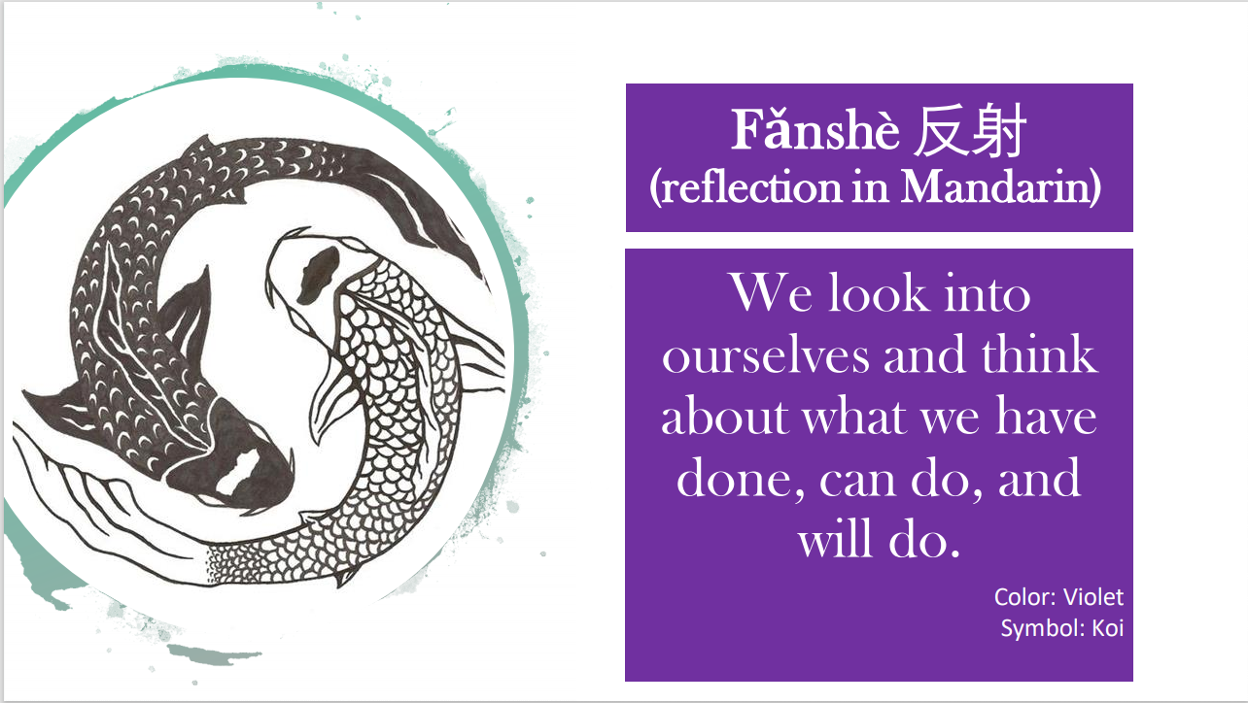 

 

Houses will plan an event for this year to bring members together to bond, create a handshake, and share ideas for next year.

**New Business:**

Grand Opening Updates: Sunday, April 25 (1:00 – 3:00pm). Invitations have been sent to dignitaries and past teachers/parents. All current families are also invited, and an electronic invitation will go out through our parent group email. We have 5th graders auditioning for a speaking role and Kindergarten students who will also give a short speech.

We are still having a problem with some students coming to school without a Mask. We have signs at car riders to remind parents and are supplying masks daily to those who come without; however, we would like parents to please be responsible for being sure their child has a clean mask each day before coming to school.

Our next Bazaar is this Friday, 3/26 beginning at 8:45am and ending around 11:30am. We need at least two parent volunteers for our Bazaar Brigade. If you can do, please contact Tonia Nathan at 321-246-7633.

Playground Recess Box is here! We could use balls and other recess-type equipment to fill the box.

**Parent Communication:** Please enjoy our April Parent Calendar (attached to this email).