Dear Parents and Families:

Get Ready! The Scholastic Book Fair is coming our way (YAY!). Choosing their own books empowers kids and inspires them to become Bolder, Prouder, and Stronger Readers. AND—as always—every book they buy earns rewards for our school.

Here’s what you need to know about the Fair, which will take place from 11/8 to 11/16 in the Media Center. Hours will be for students during regular school hours (not before or after school). ALSO, there will be a **FUN FAMILY NIGHT** from 4-6 on 11/16 in the Media Center. This is the same night as our Multi-Cultural event that is taking place in the cafeteria.

If you can’t make it to the Fair, then **shop at our school’s Online Book Fair**. All orders ship directly to your home, and shipping is free for book orders over $25. Your online orders will also benefit our school.

Visit our Book Fair homepage to learn more and get started with eWallet and online shopping:

<https://www.scholastic.com/bf/bellamyelementaryschool>

The countdown to more Bookjoy is on! Catch you at the Fair!

Happy reading,

Ms. A. Williams

Media Specialist

Bellamy Elementary School

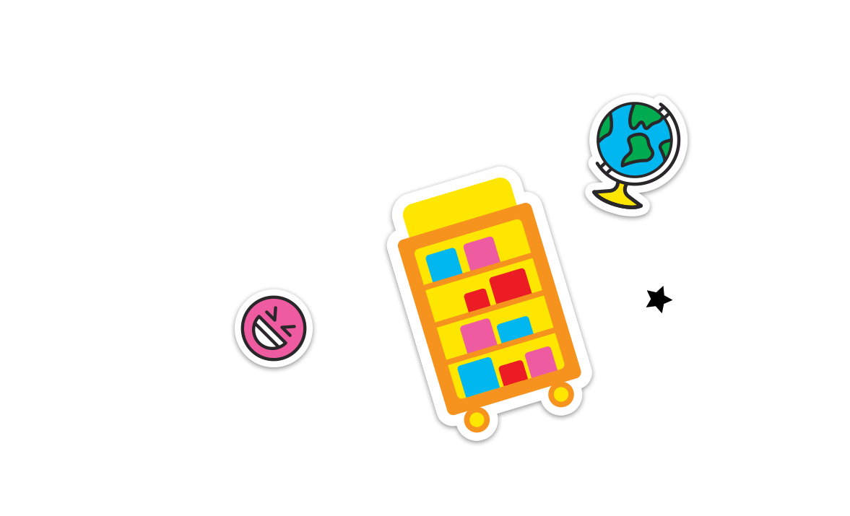

Permission to reproduce this item is granted by Scholastic Book Fairs®.

©2022 Scholastic Inc. All rights reserved. 2580250 F22 • 2580301