School Board
Lynn L. Gray, Chair
Stacy A. Hahn, Ph.D., Vice Chair
Nadia T. Combs
Karen Perez
Melissa Snively
Jessica Vaughn
Henry “Shake” Washington
Superintendent of Schools
Addison G. Davis

Date 10/01/2021

Dear Parent/Guardian:

All educators in Florida are monitored to ensure they meet certification and training requirements as mandated by law. Per Florida Statute 1012.42, when a teacher is assigned teaching duties out of the field in which the teacher is certified, the parents of all students in the class shall be notified in writing.

Hillsborough County Public Schools is committed to providing quality instruction for all students and does so by employing the most qualified individuals to teach and support each student in the classroom. The district is assisting our teachers by developing an Individual Professional Development Plan to complete the requirements needed to become in-field.

All of our teachers are certified to teach, although some of them are currently out-of-field and are working on additional areas of certification. You have the right to know the professional qualifications of the teachers or paraprofessionals who instruct your child. Federal law allows you to ask for certain information about your child’s teachers and requires us to give you this information in a timely manner if you ask for it. If you would like more information, please contact the school at 813-276-5691.

The table below lists teachers who are currently out-of-field.

Sincerely,

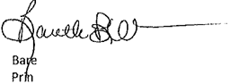
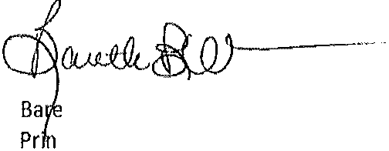
Baretta Wilson
Teacher | Classes Taught  Assignment(s) | Assignment Start Date | Certification(s) Held | Out-of-Field  Area/Classes
Michelle Fleeman | Language Arts, Reading 6 | August 10th, 2021 | Elementary Ed. Emotional Handicap, ESE Pk-12 | ESOL
Juan Ramos | Game & Sim Found, CPTR App Bus 4, Career Res. & Dec | August 10th 2021 | Engineering and Tech Ed. | Business Tech
Laura Smith | 6th grade lang. Arts.  World Histiory  Reading Adv. 1A | August 10th,2021 | Elementary Ed.  Spec. Learn. Disab. | ESOL
Lori Harris | Cptr Appl Bus 1 & CP, Career Res & Dec, Fund of Market occs, Digital Info Tech. | August 10th,2021 | Elementary ed. & ESOL | Bus. Tech

